Problems for DUPT2018
初选

Heron's Fountain
Construct a Heron’s fountain and explain how it works. Investigate how the relevant parameters affect the height of the water jet.
- Azimuthal-Radial Pendulum
Fix one end of a horizontal elastic rod to a rigid stand. Support the other end of the rod with a taut string to avoid vertical deflection and suspend a bob from it on another string (see figure). In the resulting pendulum the radial oscillations (parallel to the rod) can spontaneously convert into azimuthal oscillations (perpendicular to the rod) and vice versa. Investigate the phenomenon.
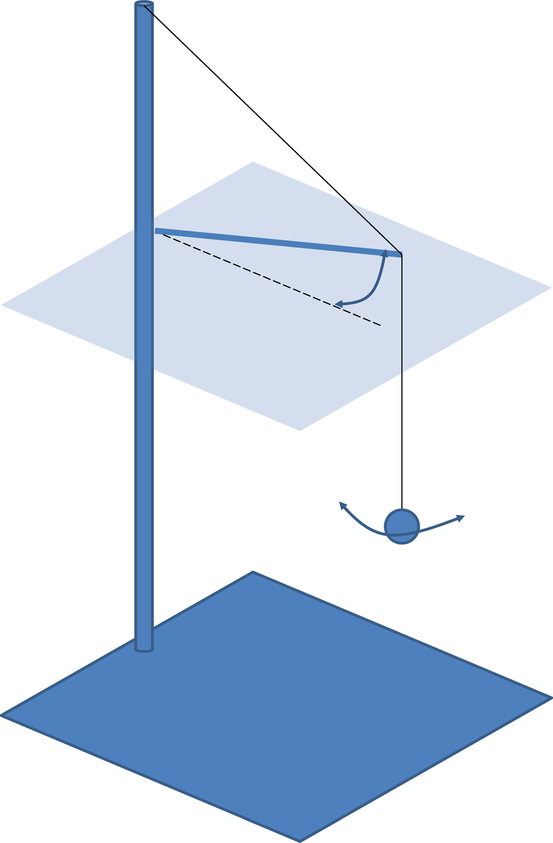

- Weighing Time
It is commonly known that an hourglass changes its weight (as measured by a scale) while flowing. Investigate this phenomenon.

